**Applying Data Mining and Machine Learning Algorithms to predict symptoms development in PD**

Andrzej W. Przybyszewski 1,2,

1University of Massachusetts Medical School, Dept Neurology, 65 Lake Av., Worcester, MA 01655, USA

[Andrzej.Przybyszewski@umassmed.edu](mailto:Andrzej.Przybyszewski@umassmed.edu)

2Polish-Japanese Institute of Information Technology,  Koszykowa 86, 02-008 Warszawa, ­­­­­Poland

Abstract

A standard treatment of PD symptoms depends on experience of the particular neurologist, measurements of UPDRS and Hoehn and Yahr scale in order to estimate stage of PD, patient’s reports and patient’s responses to medications. All these estimations are in large extend subjective and determine different treatments in different centers. The purpose of this work was to develop approach that may more precisely and objectively estimate patient’s symptoms and in consequence optimize individual PD treatment. We have demonstrated on several examples different methods that make measurements in PD more precise. But a higher precision and objectivity were only first steps. In addition, all (standard and new) data must be evaluated in an intelligible way in order to better estimate PD symptoms and their developments. We have used data mining and machine learning approaches to mimic the “golden” neurologist’s reasoning.

1. Introduction

The most popular approach to study symptoms developments in Parkinson’s disease (PD) patients is to use statistical methods. By applying statistics to large databases one can find significant information about specificity of the PD. As larger databases have information from different PD clinics, one can compare results of different treatments. But, due to a variety of cares, some of results obtained even from the most prominent expert centers might be inconsistent. Applying statistical averaging methods to such inconsistences may give confusing results even leading to statements that a specific care does not effectively influence PD patients. We might face similar problems when explaining factors that result a longer, better, and more active lives of people with Parkinson’s. Generally we agree that the control of the depression and movement therapies is the main factor helping patients. But different clinics are using different methods in dealing with depression. They also may interpret differently meanings of the UPDRS that results different therapies. These problems are articulated in a popular statement “*No two people face Parkinson’s in quite the same way”*. People vary substantially in their combination of symptoms, rate of progression, and reaction to treatment. Again averaging patients’ symptoms as effects of different cares gives a very crude approximation of the results. If we would like to improve this analysis, we need to take into account a great variety of patients’ symptoms and inconsistent effects of cares in different PD clinics.

Therefore we propose to extend the statistical analysis by the **data mining and machine learning (ML) methods** that give a higher meaning to an individual patient’s symptoms and their individual developments. In the consequence our methods will suggest a specific treatment adjusted to different individual patients that may lead in slowing down their symptoms and improve quality of their life. These treatments will be proposed on the basis of **learning algorithms** that intelligently process data of the individual patient in a specific way. Our method of the symptom classification will be similar to the complex object recognition by the visual system. The ability of the visual system to recognize various objects arises in the afferent, ascending pathways that classify properties of objects’ parts from a simple, in lower areas, to more complex, in higher areas, attributes. These primary classifications are compared and adjust by interaction with whole object (“holistic”) properties (representing the visual knowledge) in all levels by the descending pathways influences [1]. These interactions in multiple levels between measurements and knowledge with help of learning can differentiate subtle variations in symptoms and treatments similarly to study complex visual objects [2,3]. By using predictions with the support of the machine learning algorithms we will find if these subtle variations are enough significant to improve patient’s treatment.

A popular statement that “*No two people face Parkinson’s in quite the same way”* may describe Parkinson’s patient point of view on his/her disease. Patient’s self perception is subjective and depends on many factors but mostly on emotional states that are often related to the depression and motor impairments. A social support or its lack is also an important factor. Also opinions of neurologists that follow patient’s symptoms are important for the patient. However, an opinion of the neurologist is more objective as supported by objective but mostly not very precise interviews, tests and measurements of patient’s symptoms like e.g. UPDRS. Another views on patient’s states come from psychologists, caregivers or family members. These all opinions describing patient’s actual status are often not consistent and sometimes even contradictory especially if patient’s conditions fluctuate with medications and time of the day or night. To make things even more complicated there is strong dependence between different symptoms, as for example caregiver can perform exercises with a patient that give his/her good feelings but in reality may not improve patient’s motor skills.

There are many well-established patients’ symptoms measures such as the most common Hoehn and Yahr scale and total UPDRS. However, even if non-motor symptoms and motor complications are common in PD, UPDRS Parts I and IV that focus on non-motor symptoms are used infrequently. In most “PubMed” publications between 1998-2011, in all studies that have used UPDRS, 163 studies (97,6%) had included only UPDRS part III [4]. There are many different measures of PD symptoms describing actual patient state and their values mostly like UPDRS increase with time and disease progression. As there is actually no cure that can stop Parkinson’s disease development, there are only some possibilities to slow it down. The main purpose of this paper is to analyze such means by using knowledge extracted from symptoms.

We will demonstrate our approach in several examples of patients with the DBS (deep brain stimulation) therapy that is mostly used in more advance PD stages. In order to be effective, stimulating electrodes must be placed precisely in or near the STN (Subthalamic nucleus). As STN is in the most cases invisible in the MRI, the standard procedure is related to the intra-OP neuronal activity recording that helps in verifying that the microelectrode’s tip is in/near the STN. As it is not straight-forward task, and we have described (see below) how to increase and automatize this procedure using several different approaches: by looking in changes in the power spectra of the high and low (local field potentials – LFP) frequency background activity, or by using different algorithms to find properties of the spike train related to the STN. We have also discussed methods of finding an exact position of the stimulating electrode in relationship to the STN. What effects can be expected by stimulation of the specific contact of the DBS electrode as a function of its relationship to different STN parts. The central and peripheral effects related to the DBS electrode position can be estimated and precisely measured in different effectors. On the one side, we have described correlations between UPDRS and Euler hip angle changes during the gait. On another central side, we have measured correlation between UPDRS and eye movements’ pathologies. All these various measurements might help in more precise estimation and control of PD symptoms development and in consequence improve patients’ care.

2. Methods

Let us assume that a complex shape in Fig.1 represents the set of different symptoms. Our methods can measure values of symptoms with a certain precision represented by squares (granules). Therefore on the basis of our measurements we can get two approximations of patient’s real symptoms: the **lower approximation** set as squares inside the curve (Fig. 1 black squares) and the **upper approximation** set is represented by squares that covers the whole shape (gray and black squares). The lower approximation set represents all actual symptoms (values) that are certain, whereas the upper approximation set represents symptoms (values) that are not all certain. The white squares represent symptoms that are not present in the patient. The set between upper and lower approximations represent the boarder region (gray squares). This region represents symptoms that fluctuates in time or symptoms that cannot be exactly determined or measured by the neurologist. We can normalize value of symptoms in a similar way as UPDRS values (0-4). In this case, if there is no pathology/symptoms or movements are normal all values are 0. Therefore for the normal person shape-describing symptoms consist only a point.

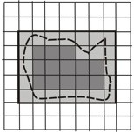

**Fig. 1.** Schematic showing possible set roughness in symptoms classification

In this model, different patients may have shapes with different complexities. The progression of the disease when symptoms become more severe correlates with the shape’s expansion. It expands differently in different patients but the area is always increasing as values of symptoms become larger. We would like to find in which direction the expansion is the fastest and try to slow it down. However, we still have several issues with this simple model. At first, symptoms are not independent so that the fastest expansion may cause or may be caused by change of other symptoms. The sensitivity of our measurements is limited, so that we do not sense symptoms changes in the boarder region, etc. Also another problem is related to the different weights of symptoms so that for example: the danger to fall is more important than slow or asymmetric walk. There is a subjective, patient’s point of view. But doctor’s point of view is to find which symptoms are the most important to follow. These knowledge neurologists are getting from their experience, but we would like to extract this knowledge from the database. Our data mining methods can tell us which measurements are important for our classifications. But in general, in order to find which symptom has the fastest grow we need to interview and observe patients. Experienced neurologist can find such difference even if the total UPDRS does not change significantly. But even in the best clinics, experienced neurologists have limited time and cannot follow all time all patients in order to perform more precise measurements. A long-term purpose of our approach is to propose a solution for these problems.

2.1. Theoretical Basis

The data structure is an important point of our analysis. It is represented in the form of information system or a decision table. We define after [5] an information system as *S =* (*U, A*)*,* where *U, A* are nonempty finite sets called the *universe of objects* and the *set of attributes*, respectively. If *a*  *A and u*  *U,* the value *a(u)* is a unique element of *V* (where *V* is a value set).

We define a **lower approximation** of symptoms set *X* * U* in relation to symptoms attribute B as *X* = {*u*  *U*: [*u*]*B  X* }, and **upper approximation** of *X* as *X* = {*u*  *U:* [*u*]*BX*}. In other words, all symptoms are classified into two categories (sets). The lower approximation set has property that all symptoms with certain attributes are part of set *X*, and the upper movement approximation set has property that only some symptoms with *B* attributes are part of *X* (for more details see [5])*.* The difference of *X and X* is defined as the boundary region of *X:* *BN B* (*X*). If *BN B* (*X*) is empty set than *X* is *exact* (*crisp*) with respect to *B*; otherwise if *BNB (X)* ** and *X* is not *exact* (i.e., it is *rough*) with respect to *B*. We say that the *B*-lower approximation of a given set *X* is the set of union of all *B-granules* that are included in the set *X*, and the *B*-upper approximation of *X* is of the union of all *B-granules* that have nonempty intersection with *X*.

The system *S* will be called a decision table *S* = (*U, C, D*) where ***C* is the condition** and ***D* is the decision attribute** [5]. In the table below (Table 1), as an example, the decision attribute *D,* based on the expert opinion*,* is placed in the last column, and condition attributes measured by neurologist, are placed in other columns. **On the basis of each raw in the table, rules describing symptoms of each patients can be proposed.** As you can see these rules have many particular conditions. The main concept of our approach is to describe different symptoms in different patients by using such rules. On the basis of these rules, using the **modus ponens rule** we want to find universal rules for different symptoms and different patients.

However, symptoms, even for same treatments are not always the same; therefore **our rules must have certain “flexibility”, or granularity, which can be interpreted as the probability of finding certain symptoms in a group of patients under consideration.**

**The granular computation simulates a way in which neurologists interact with patients.** This way of thinking relies on the ability to perceive patient’s symptoms under various levels of granularity (i.e., abstraction) in order to abstract and consider only those things that serve a specific interest and to switch among different granularities. By focusing on different levels of granularity, one can obtain different levels of knowledge, as well as a greater understanding of the inherent knowledge structure. Granular computing is thus essential in human-way, intelligent problem solving behaviors on *problem-specific* tasks.

The ***indiscernibility relation*** of any subset *B* of *A* or *I*(*B*), is defined [5] as follows: (*x, y*)  *I*(*B*) or *xI*(*B*)*y* if and only if *a*(*x*) = *a*(*y*) for every a  *B*, where *a*(*x*)  *V*. *I*(*B*) is an equivalence relation, and [*u*]*B* is the equivalence class of *u*, or a *B-elementary granule*. The family of all equivalence classes of *I*(*B*) will be denoted *U/I*(*B*) or *U/B*. The block of the partition *U/B* containing *u* will be denoted by *B*(*u*). Having in discernibility relation we define the notion of reduct *B⊂A* is a reduct of information system if *IND(B) = IND(A)* and no proper subset of *B* has this property. In case of decision tables decision **reduct is a set *B⊂A* of attributes such that it cannot be further reduced** and IND(B) ⊂ IND(d). Decision rule is a formula of the form (*ai1 = v1*) ∧ ... ∧ (*aik = vk*) ⇒ *d = vd*, where *1≤ i1 < ... < ik ≤ m, vi ∈ Vai* . Atomic subformulas (*ai1 = v1*) are called conditions. We say that rule *r* is applicable to object, or alternatively, the object matches rule, if its attribute values satisfy the rule. With the rule we can connect some numerical characteristics such as matching and support.

In order to **replace the original attribute *ai* with new, binary attribute** which tells as whether actual attribute value for an object is greater or lower than *c* (more in [6]), we define *c* as a cut ***(cut sets).*** By cut for an attribute *ai* ∈ *A*, such that *Vai* is an ordered set we will denote a value *c* ∈ *Vai*. Template of *A* is a propositional formula  *vi* ∈ *Vai*. A generalized template is the formula of the form ∧(*ai* ∈ *Ti*) where *Ti* ⊂ *Vai*. An object satisfies (matches) a template if for every attribute *ai* (*ai* = *vi*) where *ai* ∈ A. The template is a natural way to split the original information system into two distinct sub-tables. One of those sub-tables consists of the objects that satisfy the template, the second one of all others.

**Decomposition tree** is defined as a binary tree, whose every internal node is labeled by some template and external node (leaf) is associated with a set of objects matching all templates in a path from the root to a given leaf [6]. We use the decomposition tree in the ML algorithms.

2.2. Intraoperative Recordings

I will describe in short the surgery performed at UMass Medical School as described in details in [7]. Similar surgeries were performed by dr. Kwiek in SUM [8,9] and dr. Mandat [10] in the Institute of Psychiatry and Neurology (Warsaw). Surgical planning at UMass utilized the BrainLab iPlan Stereotaxy 2.6 (BrainLAB AG, Germany) which allows for multiplanar imaging of the target and the planned trajectory(s). T2 weighted and enhanced T1 MRI sequences were acquired pre-operatively. In relationship to the midcommisural (AC-PC) point, the target is expected to be 11-12 mm lateral, 3 mm posterior and 4 mm below**.**  According to the anatomy atlas the usual trajectory penetrated the following structures: anterior thalamus, zona incerta, H2 field of Forel, STN, and substantia nigra (SN).

All electrophysiological recordings were performed at UMass using a Guideline 4000 (FHC, Inc. Bowdoin, ME). Neural signals were recorded by one or more parallel tungsten microelectrodes. Recordings started 20 or 10 mm above the target (different centers). The microelectrode(s) was (were) advanced in from 1 to 0.3 mm increments. Ten second recordings were obtained at each point. Recordings were band-pass filtered in two frequency ranges: high frequency (300-5000Hz), digitized at 24 kHz related to the spike trains and low frequency range (5 – 500Hz) with sampling rate 1000Hz related to the local field potentials and stored for offline analysis [7].

The electrophysiological criteria used by neurologists to distinguish the STN were an increase in the background activity, an increase in the neuronal firing, and/or alteration of neural firing by passive movement of contralateral limbs**.** The entry to the STN corresponds to the dorsal border and the exit from the STN to the ventral border.

Off-line analyses were performed with the software written in Matlab (Matworks, Natick, MA). The STN detection is based on the profile of the MUA (multi-unit activity) that is characteristically elevated within the STN. Large spikes were automatically removed by unsupervised Daubechies-based wavelet algorithm that is spike-oriented modification of the standard wavelet-denoising algorithm with soft-thresholding [*7*]. The MUA was calculated in the frequency domain. The power spectral density was calculated over the 10-second segments of despiked neuronal activity or LFP with a Fourier transform (FFT) weighted by Hamming window. The MUA was obtained by integrating the 500-2000 Hz band in the power spectral density (psd) [*7*]. The LFP was obtained by integrating the 20-35 Hz band in psd.

The dorsal STN border was defined as the first site along a track where the MUA exceeds the MUA baseline at least by 50 % and elevation of the MUA is sustained. The baseline MUA was obtained as an average MUA from recordings ≥ 10 mm above the target that usually corresponds to the thalamic activity. The ventral border was defined as the last site along a track where the MUA reduction was 50 % compared to the average MUA within the STN and the decline in MUA is sustained [7]. Similar criteria were used for the LFP.

2.3. DTI/MRI registration to anatomical atlas

In this section we describe how to define relationship between electrode’s position and STN borders. In short, in order to determine anatomical positions of structures of interest, we have performed registration of the individual patient’s brain MRIs with the brain atlas and used postoperative MRI or CT to locate an exact position of implanted DBS electrodes [11]. In addition, in order to find, which part of the cortex might be stimulated by different contacts, we have used preoperative diffusion weighted images (DWI) acquired as apart of the standard procedure for each PD patient. However, one extra condition must be fullfield in order to get a high precision of our measurements, MRI data has to have a small slice thickness and equal spacing in all directions. We have analyzed data from nine patients with advanced Parkinson disease (PD), and with implanted DBS electrodes. As image processing tool we have used the 3D Slicer (Harvard Medical School) public domain software. As in post-operative images electrode’s contacts cannot be visible, we have estimated their positions by using physical parameters of used stimulating electrodes (Medtronic 3389) [12]. In order to estimate traced areas, coordinates of the brain have to be normalized by so-called AC-PC transform (3D Slicer). Connections between M1, SMA and STN have somatotopic properties that gave us basis to estimate expected motor effects related to stimulation of different contacts [13, 14].

2.4. MoCap (Motion Capture) method

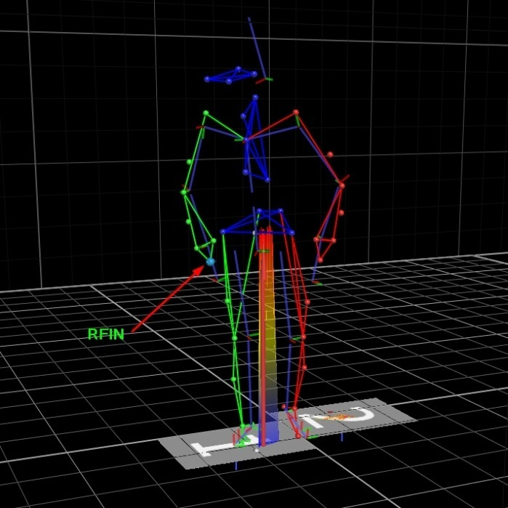In our kinematic movement recording set-up we have used 10-camera, 3D motion capture system (MoCap-Vicon) as described in [16]. The 3D body position of the patient was analyzed based on 39 reflective markers (tracked at 100 FPS) placed on major body segments: 4 on Head, 5 on Torso, 14 on left and right side of upper limbs and 16 on left and right side of lower body. Two Kistler Platforms were also recorded to analyse the Ground Reaction Forces (GRF) during patient’s movements, but we will not use GFR data in this presentation (Fig.1) [15].

**Fig.2.** MoCap set-up

We have performed experiments on 12 Parkinson Disease (PD) patients who have undergone the surgery in Dept. of Neurosurgery Medical University of Silesia (MUS, Poland) based on implanting Deep Brain Stimulator (DBS) for improving their motoric skills.

Patients were qualified for surgery and observed postoperatively in the Dept. of Neurology MUS [9,10]. All experiments were performed in MoCap lab of PJIIT in Bytom (Polish-Japanese Inst. Information Technology, Bytom, Poland). PD patients performed normal walking under four experimental conditions (S1-S4 –see below) defined by pharmacological medication and subthalamic nucleus (STN) electrical stimulation (DBS).

2.5. Eye movement measurements

The characteristic motor symptoms of PD, predominantly due to progressive degeneration of nigral dopaminergic neurons, are initially subtle and impact purposeful movement, and are often difficult to diagnose and to differentiate from other age related symptoms. An easy and objective method to measure PD patient symptoms is by testing patient’s eye movements.

We have conducted horizontal RS (reflexive saccades) measurements in nine patients with Parkinson ́s disease (PD) in four sessions: S1: MedOffDBSOff, S2: MedOffDBSOn, S3: MedOnDBSOff, S4: MedOnDBSOn. Changes of motor performance, behavioral dysfunction, cognitive impairment and functional disability were evaluated in each session according to the UPDRS. RS were recorded by head-mounted saccadometer (Ober Consulting, Poland).

We have used the infrared eye track system coupled with the head tracking system (JAZZ-pursuit – Ober Consulting, Poland) in order to get a high accuracy and precision in eye tracking in order to compensate possible subject’s head movements relative to the monitor. Therefore, subjects do not have to be positioned in an unnatural chinrest. A patient was sited at the distance of 60-70 cm from the monitor with head supported by the chair in order to minimize it movements. We have measured the fast eye movements in response to the light spot switch off-on and move horizontally from the straight eye fixation position (0 deg) to 15 deg to the left or 15 deg to the right after arbitrary period of time: 0.5–1.5 s. When patient fixates his/her eyes on the spot in the middle marker (0 deg) the spot will change color: from white to green, which means that patient should perform RS (reflexive saccades); or from white to red meaning to perform AS (antisaccades). Then the central spot will be switched off and one of the two peripheral targets, select at random with equal probability, will be illuminated instead. The patient has to look at the targets and follow them as they move in the RS task or make opposite direction saccades in the AS task. After making a saccade to the peripheral target, the target will remain on for 0.1 s and then another trial will begin. In each test the subject had to perform 20 RS and 20 AS in a row in Med-off in two situations: with DBS off (S1) and DBS on (S2). In the next step patient took medication and had a break for half to one hour, then the subject has performed same experiments with DBS off (S3) and DBS on (S4). In this work we have analyzed only RS data using the following population parameters averaged for both eyes: delay mean +/-SD; amplitude mean +/- SD; max velocity mean +/-SD; duration mean+/-SD.

3. Results

3.1. Intraoperative Recordings

The purpose of this part is to demonstrate an increase in the precision and automaticity if in addition to STN border found by the neurologist-neurosurgeon team one use supplementary signals: power spectrum of the background activity – MUA and/or power spectra of LFP (p_LFP). We have already demonstrated good correlations between MUA and IOM (intra-OP monitoring – the standard procedure) using statistical approach. Here we have demonstrated the use data mining (RSES) and machine learning (ML) methods.

3.1.1. Spike Trains, Background Activity and Local Field Potentials

As we have described in the Methods section, in UMass experiments we have compared STN boarders estimations by three different methods: 1) classical “golden standard” IOM (intra-operative monitoring); 2) MUA – an increase of the power spectrum in the high frequency background multi unit activity (HFBA) [*7*]; 3) p_LFP – an increase in the power spectrum of the local field potentials [16].

In Fig. 3 we have plotted results of these three methods together in one plot. The gray area is related to the IOM found during surgery by the neurosurgeon-neurologist team. The continuous line plot represents spline approximation of the HFBA power spectra – MUA (interrupted line curve). It is very good agreement between IOM and MUA. The third curve (interrupted line) represents power spectra of the LFP with the STN borders estimation. This curve is not very exact but only in approximate agreement to other measures. A question arises if the measure of the LFP can help in the STN border estimation, even if it is not very precise measure?

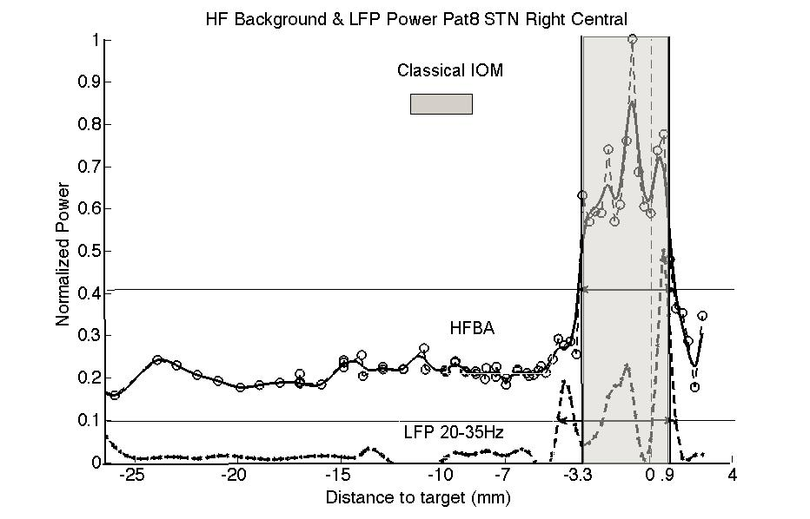

**Fig.3.** Comparison of the MUA – multi unit HFBA (high frequency background activity) and LFP (local field potentials) power spectra with STN borders determined by classical IOP (intra-OP monitoring – the gray area).

As we have demonstrated before [7] the mean difference between IOM (intra-OP monitoring) and MUA (multi-unit power spectra background activity) of the dorsal/ventral border was 0.31 ± 0.84/0.44 ± 0.47 mm.

Correlation between dorsal border/ventral border positions obtained by IOM and MUA was 0.79, p < 0.0001/0.91, p < 0.0001 [7]. However, we did not ask question how good could we predict STN borders on the basis of MUA in individual patients? For example for Pat 10L we have got good agreement between IOM and MUA for STN dorsal boarder and a large difference between both methods in the STN ventral boarder estimation in the left side. What difference should we expect in both methods agreement for the right side for that we have only IOM measurements?

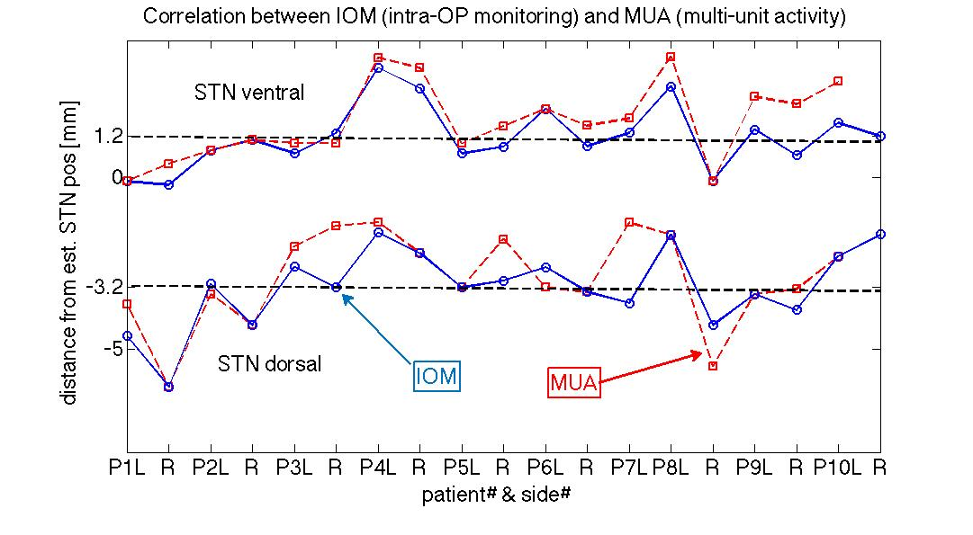

**Fig.4**. Comparison of STN dorsal and ventral border determination by the standard intra-op monitoring (IOM) and the multi unit background activity (MUA).

We did not respond to above questions using data mining RS theory, as in this case question was too demanding for our limited number of measurements. However, we were more successful in responding to similar question in another series of the intra-OP recordings [17-20] performed by a team of dr. Mandat [10]. All recordings were divided into two groups: related to spike trains and to background activity. Spikes were detected on the basis of their amplitude and sorted into different shapes. In the first group main properties (attributes) were: 1) average number of recorded spikes; 2) spike burst ratio (percentage of intra-spike intervals shorter than $33 ms)$. However, these attributes may give both false positive (highly active non STN neurons) and false negative (less active STN parts) results. In the second group main attributes were: 1) relative amplitude of the background activity (80th percentile - denoted as PRC80; 2) Root Mean Square (RMS) calculated for the recorded signal; 3) LFB (low frequency background power) for frequencies below 500Hz; 4) HFB (high frequency background power) for frequencies 500 – 3000 Hz [17,18]. There were also used additional attributes obtained by moving average of the primary attributes [19]. Ciecierski et al [20] have used in addition to RSES also Weka Random Forest classifier. Both methods in the 10-folds cross validation gave excellent discrimination between recordings made within the STN and outside of it. It was based on the comparison of the neurologist expertise with results of classifications. The sensitivity was about 93% and specificity about 99% [20]. The second coefficient is even more important as it minimize the probability of the labeling non-STN region as STN. These results are very promising as they were based on not only very large numbers of recordings (over 16000) but also on many different attributes describing signals recorded on different depths. As the system is already used in on-line surgeries it may lead to increase speed and precision of the DBS surgery.

3.2. Improving DBS parameters in relationship to electrode’s contacts positions

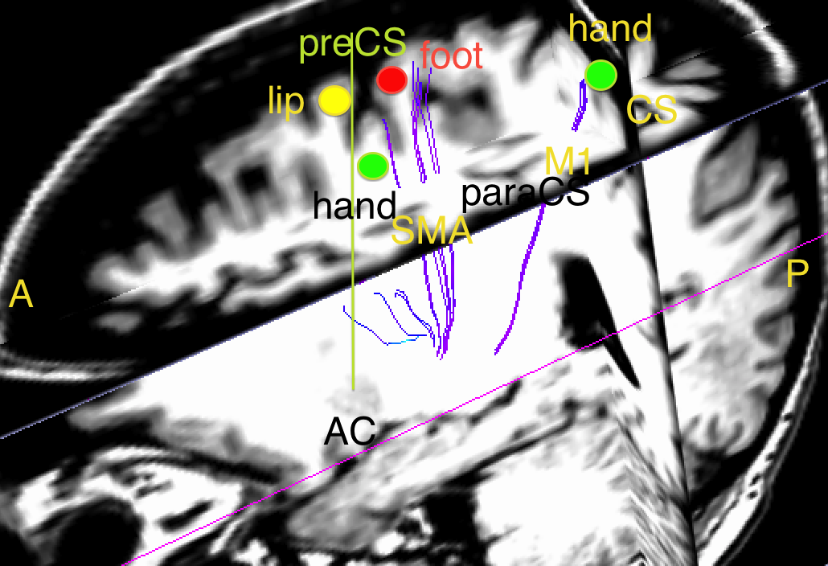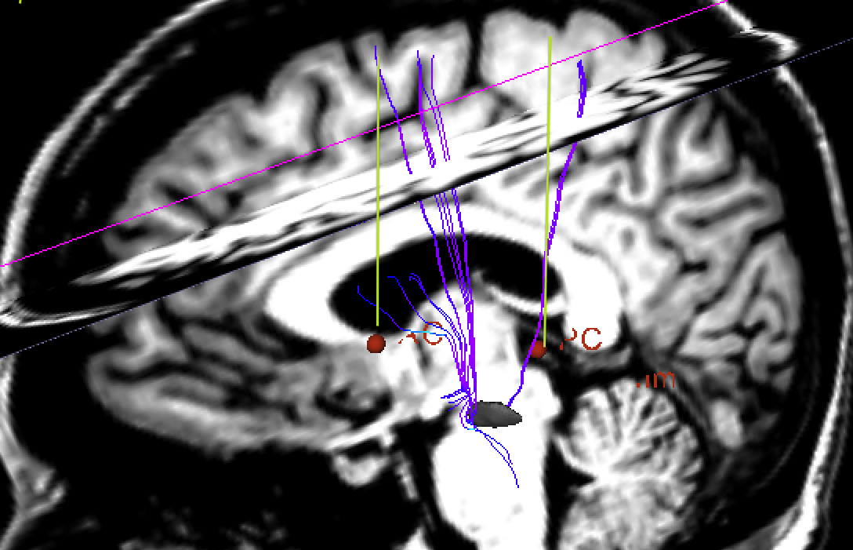 In this session, we demonstrate MRIs of one PD patient with implanted DBS electrodes. Fig. 5 shows sagittal images of pat#5 the left brain with marked tracts generated from the contact #1 of the DBS electrode. The STN tracts have endings in the primary (M1) and suplamentary (SMA) areas. In M1 they come near the area representing “hand”, in area SMA posterior to precentral sulcus near are representing “foot”.

**Fig. 5** There are two MRI images of the same area of Pat#5 with different views. These are mainly sagittal also with axial and coronary MRI images of the left hemisphere with marked neural pathways between the contact #1 left DBS electrode and different cortical areas. A, P – anterior, posterior; AC, PC – anterior, posterior commiserate that determine area of interest: between preCS and CS; SMA – supplementary motor area; M1- primary motor area; CS – central sulcus; paraCS – para-central sulcus; preCS- precentral sulcus; lip, hand, foot – somatotopic areas representing lip, hand, foot. The STN is visible in the left image.

The results of patient #5 pre-Op neurological examinations were: dystonic cramps in feet, freezing gait, falls, mild depression, rigid, minor tremors in legs and hands, cramping in left foot, later in both feet, Effects of the DBS contact #1 stimulations on the left side were: improved dexterity and limb tone was normal in the right upper extremities, restless leg symptoms off. Fig. 5 supports such findings, as there are tract’s endings near foot and hand areas in the left hemisphere. Our question was if on the basis of our anatomical tracts can we predict which contact and what the amplitude of the stimulation should be in order to improve particular symptoms?

In order to test this possibility, we have divided our data of 20 objects in 4 random groups. We have used 3 groups together for the training and tested found in training rules on the fourth group. In the next step, we have changed one tested and training group and checked our predictions again. We have performed testing for all groups by the cross validation method. We have obtained total accuracy 75 – 80% that give good prediction for such small dataset [11]. By using this method we may increase effectiveness of choosing optimal stimulating parameters as well as try to test parameters that may improve particular symptoms.

3.3. Gait measurements and classifications

In this simple example we concentrate only on PD pathologies of the normal gait, and present several different approaches to compute important features of gait abnormalities. This is a continuation of our previous experimental results concerning examination of Parkinson’s disease (PD) with bilateral subthalamic nucleus stimulation (DBS) patient in the MoCap laboratory. At first, in the statistical approach, we calculate mean changes of the gait as effects of medication and DBS (deep brain stimulation of STN). In the second approach, we present gait parameters changes in the phase plots that demonstrate a different dynamics in different patients. In the third part, we apply the data mining approach related to application of the Rough Set Theory in order to generate decision rules for all our patients and all experiments. We have tested these rules by comparing training and test sets using the machine learning methods.

There were many studies where diagnosis of human gait abnormalities is measure in more precise way than the result of the UPDRS test. In our previous work, we have computed indexes for neurological gait abnormalities for PD patients with DBS [15]. We have found a strong influence of the medication and DBS on the decomposition index of knee and hip and hip and ankle. Therefore in this presentation we have concentrated analysis on the dynamics of the hip movements during the gait [21].

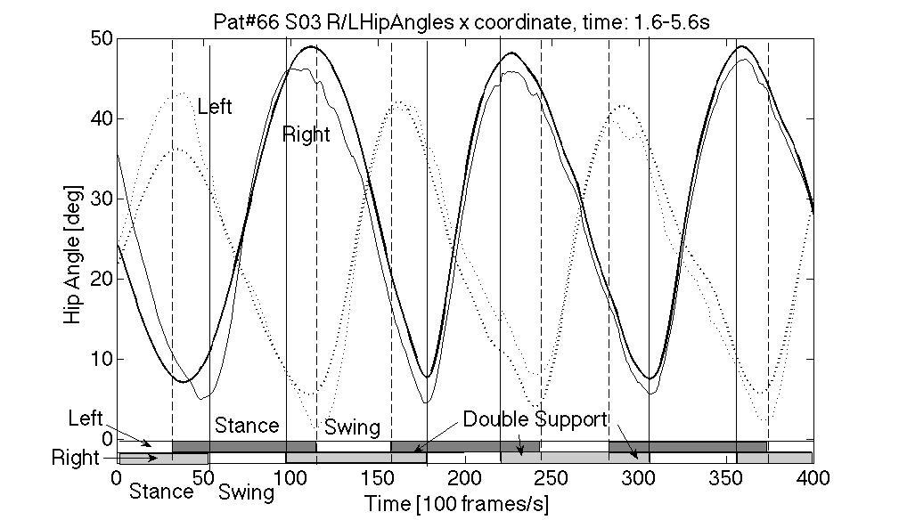However, the present approach is different from our previous work as now we intend to use not only statistical analysis of certain indexes, but also **data mining approach** base on the rough set theory. This new approach not only summarizes actual measurements but also gives some strong predictions that might be better than standard indexes, which also can predict effects of different therapies for PD patients. As effects of medications and DBS are very different in different patients making predictions is very difficult task and we present here only the preliminary data.

**Fig. 6** This plot shows changes in the hip Euler angle during walking for the right and left sides. In addition to hip angle changes (thin line) their smoothed changes (thick lines) by the emd (elementary mode decomposition) were plotted together. In the lower part two phases of the gait were marked. Velocities in both gait’s phases were plotted below.

The mean for all patients *UPDRS III* were improving with sessions, **S1**: 53+/- 4 (SE), **S2**: 35+/-6, **S3**: 22+/-3.5, **S4**: 18+/-3. Mean duration of three consecutive steps were similar between sessions: **S1**: 3.9+/- 0.2s (SE), **S2**: 3.6+/-1.6s, **S3**: 3.6+/-1.4s, **S4**: 3.5+/-1.2s. These values are similar to slow walk of the healthy person. In this study, we have limited our analysis to x-direction changes in the hip angles for left and right legs during three consecutive steady steps of all PD patients [21].

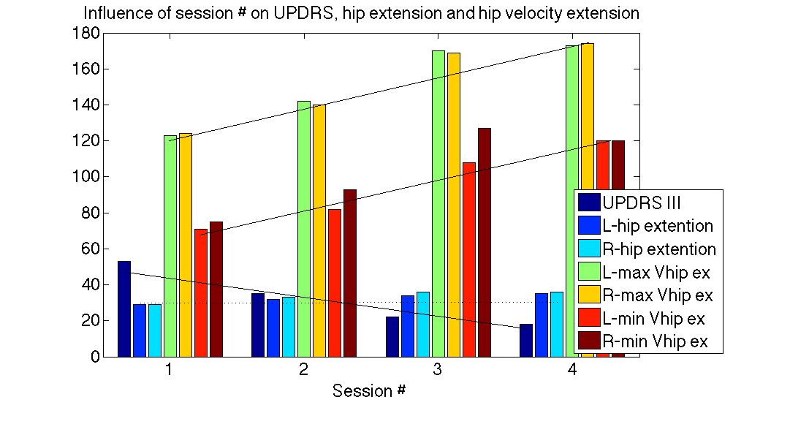**Fig. 7.** This plot shows parallel changes in UPDRS III and left- and right-hip x-angle extensions, and left-, right maximum velocities during swing and stance (marked as max/min velocity) phases as effects of medication and STN stimulation (sessions 1 to 4). Straight lines approximate decrease UPDRS with session number and increase velocities promotionally to the session number. Hip amplitude stays approximately independent on the session number (interrupted line).

The means of the *maximum x-direction hip angles extension* (swing phase) for left (L) and right (R) sides were symmetric and improved non-significantly between sessions, **S1**: L: 29+/-3 deg (SE), R: 29+/-3 deg (SE), **S2**: L: 32+/-3 deg, R: 33+/-3 deg, **S3**: L: 34+/-3 deg, R: 36+/-3 deg, **S4**: 35+/-4 deg R: 36+/-3 deg. We also found non-significant improvements for the *x direction hip angle flexion* (stand phase) between sessions. However, we have observed more significant improvements in the *maximum velocity of the x-direction hip angles extension* (velocity in the swing phase): **S1**: L: 123+/-8.5 deg/s, R: 124+/-9.5 deg/s; **S2**: L: 142+/-6 deg/s, R: 140+/-8.4 deg/s; **S3**: L: 170+/-6.5 deg/s, R: 169+/-9 deg/s; **S4**: L: 173+/-6 deg/s, R: 174+/-9 deg/s; and *hip angle flexion speed* (velocity in the stand phase): **S1**: L: 71+/-8.5 deg/s, R: 75+/-5 deg/s; **S2**: L: 82+/-6 deg/s, R: 93+/-6 deg/s; **S3**: L: 108+/-7 deg/s, R: 127+/-8 deg/s; **S4**: L: 120+/-9 deg/s, R: 120+/-9 deg/s (Fig. 7) [21].

Notice that the most significant increase in velocities was between sessions S1 and S3, so it is an effect of medications. On the basis of mean values for all our patients we can say that medication as well as DBS are improving patients’ UPDRS and (hip) movements velocities. The L-DOPA medications as well as DBS are well-established methods so one would expect such results. However, **individual patients are very different** and even in our small patients populations we have observed significant variability of the medication and stimulation effects. Therefore, we would like to learn, if we can group effects of medication and DBS therapies of individual patients into several categories?

In addition to statistical analysis, we have tried two different methods; the first one was related to the **dynamical system analysis** and the second to the **machine learning** approach. In our first method, we have compared phase plots for individual patients in four sessions S1 to S4. We have plotted the movement trajectories in the phase space as changes of the right hip x-angles as a function of the left hip angles changes during three steps stable walk. We have found different types of attractor changes as effect of medication and stimulations, as it is demonstrated on the following figures.

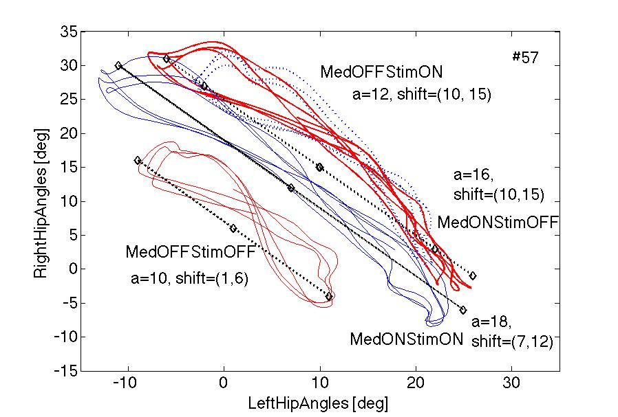

**Fig. 8.** Phase plots of the right against left x direction hip angles during the gait in two different

patients. On the left: stimulation and medication extend trajectories and shift them up and to the right. On the right: medication extends trajectories and shifts them down.

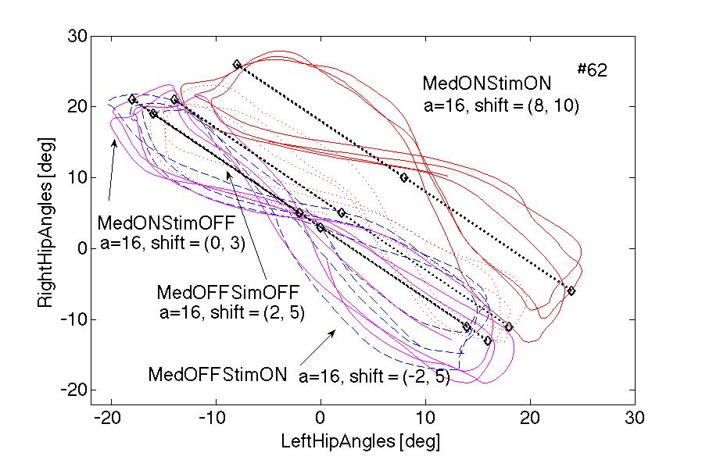

**Fig. 9.** Phase plots of the right against left x hip angles during walking in two patients. On the left: v. small effects of stimulation alone, medication also has small effects: extends trajectories and shifts them up. On the right: v. small differences between S1, S2 and S3 in S4 (MedON, StimON) shift to the right.

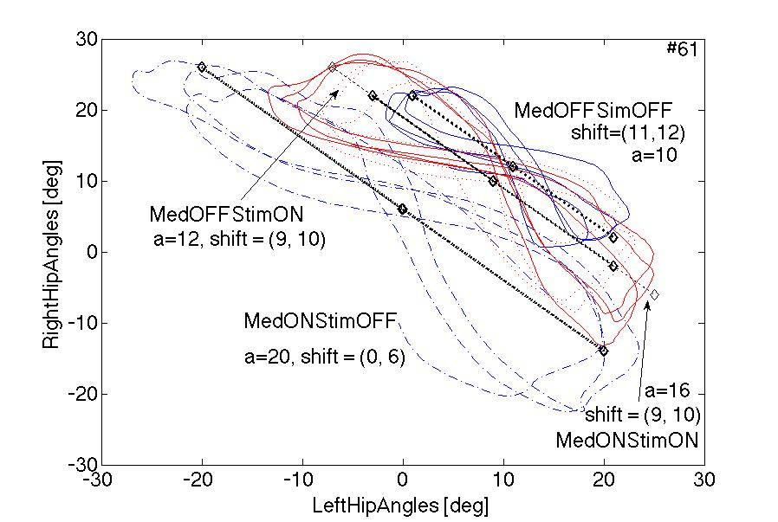

**Fig. 10.** Phase plots of the right against left x hip angles during walking in two patients. On the left, additive effects: both stimulation and medication alone shift trajectories up with extension, both together have stronger effects. On the right, when medication OFF, stimulation extends amplitude of trajectories, medication increase their amplitude even stronger and shifts down, when MedON and StimON shifts trajectories again up.

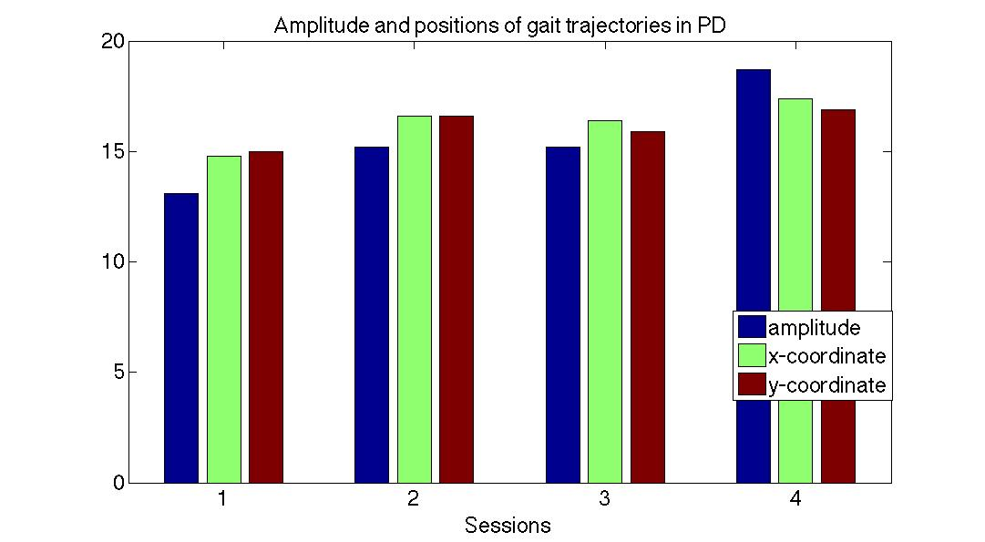

**Fig. 11.** This plot shows parallel changes in left-right angle trajectories amplitude, x- and y- coordinates during walk as effects of medication and STN stimulation.

In summary, stimulation and medication generally increase the amplitude and shift trajectories related to PD patients walk activity. It is not mainly related to patients gait speed, as mean gait durations were similar in all sessions. These plots might give basis for the dynamical model of the gait in different sessions but as demonstrated, in different patients changes of the particular trajectory are difficult to predict, as they are effects of the system complexity and basal ganglia regulatory numerous loops interactions.

Data Mining - Rough Set System Approach

As described above we have used the RSES 2.2 (Rough System Exploration Program) [22] in order to find regularities in our data. At first our data was placed in the decision table as originally proposed by Pawlak [5]. In each row of the decision table there are following condition attributes: P# - patient#, S# - Session#, t - time, mxaL/mxaR/mnaL/mnaR – max/min Left/Right hip x-direction angles, mxVaL/mxVaR/mnVaL/mnVaR – max/min Left/Right hip x-direction velocity, and UPDRS III as measured by the neurologist in the last column. There are data from two out of 12 patients in the table below:

**Table .** Extract from the information table.

|  |  |
| --- | --- |
| P# S# time mxaL mxaR mnaR mnaL mxVaL mxVaR mnVaL mnVaR UPDRS | |
| 59 1 455 29.1 32.3 -0.04 -0.86 0.91 0.91 -0.60 -0.66 30  59 2 350 34.7 35.6 -1.25 - 9.07 1.77 1.77 -0.99 -1.31 20  59 4 350 31.9 35.9 -3.29 -8.19 1.67 1.67 -1. 00 -1.24 6  61 1 305 20.7 22.9 -0.92 1.35 1.28 1.28 -0.61 -0.69 60  61 2 440 22.4 25.9 -8.05 -5.87 1.31 1.31 -0.53 -0.68 40  61 3 410 21.1 25.1 -23.4 -21.77 1.98 1.98 -1.05 -1.30 21  61 4 400 24.4 27.2 -12.0 -10.58 1.56 1.56 -0.93 -0.82 31 |
|  | |

The last column represents a decision attribute then we can write each row a decision rule as following:

*('Pat'=59)&('Sess'=1)&('time'=455)&(‘mxaL’=29.1)&(‘mxaR’=32.3)&… =>('UPDRS'=30)* ()

We read this rule as following: if for patient #59 and session S1 and time of his/her three steps was 4.55 s and max left hip x-direction angle equals 29.1 deg and max right hip x-direction angle equals 32.3 deg and … then his/her UPDRS III for these conditions was 30.

Therefore we have obtained 46 decision rules directly from our measurements, as two from our 12 patients did not have all four sessions (e.g. pat#59). The main purpose of our analysis is to reduce these rules and to find regularities in our data. There are many possible steps as described in [*22*], below we will give some examples.

At first, we would like to make rules shorter and find that they apply to more than one case, e.g.:

*('Pat'=60)=>('UPDRS'=9[2]) 2* ()

*('mnVaL'=-0.6756)=>('UPDRS'=32[2]) 2*  ()

it reads that Pat# 60 obtained UPDRS=9 in two sessions (eq. 2) and that min velocity of the left hip equal -0.6756 (- is related to the direction of gait) was related to UPDRS=32 in two cases (eq.3). In order to make rules more effective RSES can find optimal linear combinations of different attributes like:

*'mxVaL'*0.594+'mxVaR'*(-0.804)* ()

*'mx_aL'*0.046+'mn_aL'*(-0.587)+'mn_aR'*0.807* ()

and these linear combinations may be added as additional attributes. Also we can use discretization procedure [22] that divides attributes values into non-overlapping parts:

*('Pat'="(58.5,Inf)")&('Sess'="(2.5,3.5)"|"(3.5,Inf)")&('mnVaL'="(-0.9803,Inf)")=> ('UPDRS'=32[3]) 3* ()

That reads that for patients that have numbers above 58.5 and in sessions S3, S4 min hip velocity was -0.9803 or above then UPDRS equals 32 in three cases (eq. 6).

As we have demonstrated above rules determining possible UPDRS are important but from patient and doctor points of view, the first message should be if the actual therapy (medication and/or DBS) is effective. In order to find it, we need to correlate our measurements with the session number that is related to the specific procedure. In this case the session number will become the decision attribute, in other words we change columns of the decision table (Tab. 1) in such way that the session numbers will be moved to the last column and become decision attributes. Notice that session numbers may simulate symptoms development in time (in the reverse direction S4, S3, S2, S1). In this case, we can obtain the following more general rules e.g.:

*('UPDRS'=52|53|43|56|87|45|58|30|60)=>('Sess'=1[11]) 11* (7)

*('UPDRS'=23|13|43|22|39|28|24|81|48|42)=>('Sess'=2[11]) 11* (8)

*('time'=440|305|280|365|310)=>('Sess'=2[6]) 6* (9)

that means that session S1 (MedOFFStimOFF) is related to high UPDRS in 11 cases (eq. 7), in session S2 (MedOFFStimON) UPDRS are generally smaller in 11 patients (eq. 8) and in this session (S2) the duration of three steps is between 2.8 and 4.4 s in 6 cases (eq. 9). We can also for example find rules in which the duration of three steps are similar as in (eq. 10):

*('time'=350)&('Pat'=56|57|62|59)=>('Sess'=4[4]) 4* (10)

In the next two examples we will demonstrate how can we use general rules to predict the session number (or symptoms development in time) or UPDRS values in-group of patients that do not have these measurements that may mimic a group of a new patients. We will use the machine learning algorithms (ML). The main purpose of the ML approach is to demonstration that proposed rules are enough universal to predict results from new patients on the basis of already measured patients (*test-and-train scenario* – [6,22]). In order to perform such test, we have divided our data set into two parts: one 60% of our data was training set, and another 40% was set that has been tested. We have removed decision attributes from the test-set and compared them with attributes values obtained from our rules. We have used several different algorithms in order to find rules from training-set. The exhaustive algorithm [22] gave the best results described in the confusion matrix below:

**Table .** Confusion matrix for different session numbers (S1-S4).

Predicted

|  |  |  |  |  |  |
| --- | --- | --- | --- | --- | --- |
|  | **2** | 3**3**3 | 4**4** | **1**1 | **ACC** |
| **2** | 2 | 0 | 0 | 1 | **0.66** |
| **3** | 1 | 0 | 1 | 2 | **0.0** |
| **4** | 1 | 3 | 1 | 0 | **0.2** |
| **1** | 0 | 1 | 1 | 2 | **0.5** |
| **TPR** | **0.5** | **0.0** | **0.33** | **0.4** |  |

Actual

TPR: True positive rates for decision classes, ACC: Accuracy for decision classes.

Coverage for decision classes: 0.75, 1.0, 1.0, 0.66 and global coverage=0.8421, and global accuracy=0.3125. The best prediction was for the session 2 with the accuracy 0.66 (Tab. 2), and session 1 with accuracy 0.5, other session did not get good predictions. The global accuracy over 31% was not very good. It is probably related to a small set of data. It means that we probably need to use more rules as for example combinations of many attributes or/end extend number of measured attributes for our analysis.

However problem with this approach is that its results depend on which part of our measurements was taken as training and which part was tested. In order to test in exhaustive manner or all different possibilities we have divided our experimental randomly set into 9 subsets. In next nine steps we have removed decision attributes from one set and all others used to for training and prediction of the removed attributes from the test set. After 9 tests for all parts results were averaged. We have performed these tests for the UPDRS as the decision attribute. Before all tests UPDRS were divided into 6 classes and predictions with actual results were compared for each class as is summarized below in the confusion matric:

**Table .** Confusion matrix for the UPDRS as the decision attribute.

Predicted

|  |  |  |  |  |  |  |  |  |  |  |
| --- | --- | --- | --- | --- | --- | --- | --- | --- | --- | --- |
|  | 50,69.5 | -Inf,29.5 | 42.5,50 | | 34,42.5 | | | 69.5,Inf | | 29.5, 34 |
| 50, 69.5 | 0.67 | 0.0 | | 0.0 | | 0.0 | 0.0 | | 0.0 | | |
| -Inf, 29.5 | 0.0 | 1.67 | | 0.0 | | 0.11 | 0.11 | | 0.0 | | |
| 42.5,50 | 0.0 | 0.0 | | 0.11 | | 0.0 | 0.0 | | 0.0 | | |
| 34,42.5 | 0.0 | 0.11 | | 0.0 | | 0.0 | 0.0 | | 0.0 | | |
| 69.5, Inf | 0.0 | 0.11 | | 0.0 | | 0.0 | 0.0 | | 0.0 | | |
| 29.5, 34 | 0.0 | 0.0 | | 0.0 | | 0.0 | 0.0 | | 0.22 | | |
| TPR | **0.44** | **0.71** | | **0.11** | | **0.0** | **0.0** | | **0.22** | | |

A

C

T

U

A

L

**TPR:** True positive rates for decision classes, **ACC:** Accuracy for decision classes: 0.44, 0.72, 0.11, 0, 0, 0.22. Coverage for decision classes: 0.44, 0.60, 0.11, 0.11, 0.11, 0.17 and global coverage=0.6, and **global accuracy=0.917**. UPDRS decision classes: (50, 69.5), (- Inf, 29.5), (42.5, 50), (34, 42.5), (69.5, Inf), (29.5, 34).

**If we look at the global accuracy, it is about 92% so we have a good agreement between predicted and actual UPDRS values. The reason is that over half of all UPDRS values are below 29.5 and they were very well predicted as well as UPDRS values between 50 and 69.5, (42.5,50), and (29.5,34). It is good a result even if the global coverage =0.6 is not great.**

3.4 Reflexive saccades measurements and classifications

The patients’ mean age was 51.1±10.2(SD) years, mean disease duration was 11.3±3.2 years, mean UPDRS: S1: 66.6±13.8 S2: 30.0±16.3; S3: 58.1±13.5; S4: 22.3±13.6; mean UPDRS III: S1: 42.7±11.3 S2: 17.8±10.6; S3: 34.1±10.8; S4: 10.9±8.3;  mean RS latencies: S1:291.2±93.1ms, S2: 199.6±39.5ms, S3: 232.9±82.7ms; S4: 183.2±30ms.

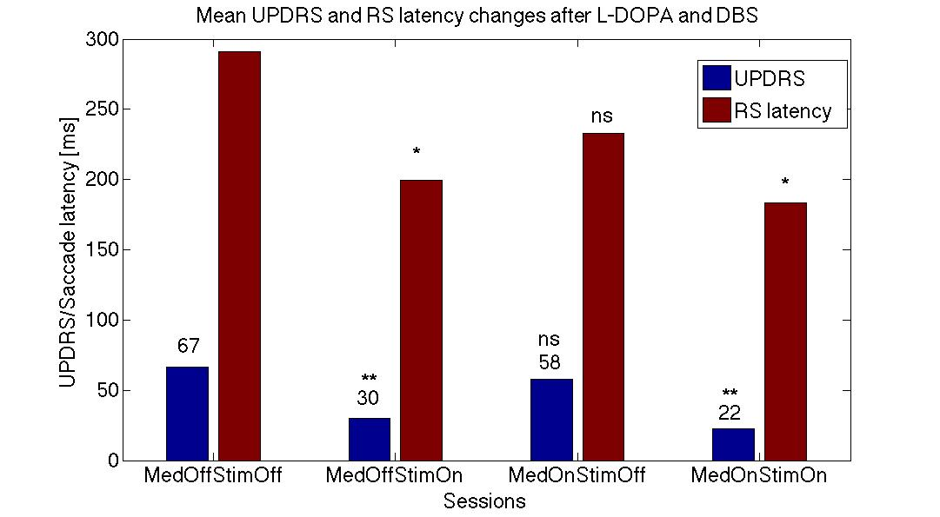Differences between latencies: S1-S2, and S1-S4 were stat sig (t-test p< 0.01), S1-S3 - not stat sig., similar to differences between UPDRS/UPDRS III: S1-S2, and S1-S4 were stat sig (t< 0.001) and S1-S3 - not stat sig. [23]. Other parameters of RS did not change significantly with the session number.

**Fig. 11.** This plot shows parallel changes in UPDRS and reflexive saccade’s latencies as effects of medication and STN stimulation. Changes between control and Med*StimOn were significantly different for UPDRS p<0.001 (**), RS p<0.01 (*)

**Table .** Extract from the information table.

|  |  |
| --- | --- |
| P# age sex t_dur S# UPDRS HYsc SccDur SccLat SccAmp SccVel | |
| 28 54 1 8 1 58 2.0 43 402 12 566,9  28 54 1 8 2 40 1.0 46 297 11 474,5  28 54 1 8 2 40 1.0 49 227 10 431,2  28 54 1 8 4 16 1.0 47 198 9 376,2  38 56 0 11 1 49 2.5 42 285 14 675,2  38 56 0 11 2 22 1.5 48 217 12 509,7  38 56 0 11 3 37 2.5 43 380 14 638,9  38 56 0 11 4 12 1.5 45 187 10 482,6 |

The full table has 11 attributes and 32 objects (measurements). In each row of the decision table there are following condition attributes: P# - patient#, age – patient’s age, sex – patient’s sex: 0 - female, 1 – male, t_dur – time of the disease, S# - Session#, UPDRS – total UPDRS, HYsc – Hoehn and Yahr scale all measured by the neurologist and saccades measurements: SccDur - saccade’s duration; SccLat - saccade’s latency; SccAmp – saccade’s amplitude, and SccVel – saccade’s velocity. In the next step, we have performed reduction of the attributes (see reduct in the Method section) to minimum number of attributes describing our results. In the following step, we have performed table discretization that mean that single values of measurements were replaced by their range (as describe in the Method section: cut sets). As the result we have obtained the decision table (Tab. 5 –see below).

**Table .** Extract from the decision discretized-table

|  |  |
| --- | --- |
| P# age t_dur S# HYsc SccDur SccLat SccAmp UPDRS | |
| 28 "(-Inf,55.0)" * 1 * "(-Inf,45.5)" "(260.0,Inf)" "(10.5,Inf)" "(55.0,Inf)"  28 "(-Inf,55.0)" * 2 * "(45.5,Inf)" "(260.0,Inf)" "(10.5,Inf)" "(22.5,55.0)"  28 "(-Inf,55.0)" * 2 * "(45.5,Inf)" "(-Inf,260.0)" "(-Inf,10.5)" "(22.5,55.0)"  28 "(-Inf,55.0)" * 4 * "(45.5,Inf)" "(-Inf,260.0)" "(-Inf,10.5)" "(14.0,22.5)"  38 "(55.0,Inf)" * 1 * "(-Inf,45.5)" "(260.0,Inf)" "(10.5,Inf)" "(22.5,55.0)"  38 "(55.0,Inf)" * 2 * "(45.5,Inf)" "(-Inf,260.0)" "(10.5,Inf)" "(14.0,22.5)"  38 "(55.0,Inf)" * 3 * "(-Inf,45.5)" "(260.0,Inf)" "(10.5,Inf)" "(22.5,55.0)"  38 "(55.0,Inf)" * 4 * "(-Inf,45.5)" "(-Inf,260.0)" "(-Inf,10.5)" "(-Inf,14.0)" |

In the first column is patient’s number, in the second: patient’s age divided in our group as patients below (Pat#28) or above (Pat#38) 55 years of age; disease duration and Hohn and Yahr scale were not important (stars), session’s number is the same; and other parameters of saccades were also divided into ranges. It is interesting how UPDRS were divided into different ranges: above 55, 22.5 to 55, 14 to 22.5, and below 14 (the last column). On the basis of the decision table we can write the following rule:

*('Pat'=28)&('age'="(-Inf,55.0)”)&('Sess'=1)&('SccDur'=”(-Inf,45.5)")&('SccLat' =”(260.0,Inf)")& (' SccAmp')="(10.5,Inf)") => ('UPDRS'="(55.0,Inf)" ) (11)*

We read this as formulas above (eqs. 1-10), and each row of the table (Tab. 5) can be written in form of this equation (eq. 11). These equations are parts of the data mining system bases on Rough Set Theory [5]. On this basis we have found more general rules describing our measurements in a similar way as it was mentioned above (eqs. 6-9). In the next step, we have tested our rule using the machine-learning concept. We have randomly divided our data into 4 groups, we took 3 groups as a training set and the fourth was tested. By changing groups belonging to the training and test sets, we have removed effect of the accidental division. The results of each test were averaged. It is called 4-fold cross-validation that gave as a results the confusion matrix (Tab. 6). As a machine-learning algorithm we have used the decomposition tree (see Methods).

**Table .** Confusion matrix for different session numbers (S1-S4).

Predicted

|  |  |  |  |  |  |
| --- | --- | --- | --- | --- | --- |
|  | **55.0,Inf** | **22.5,55.0** | **-Inf, 14.0** | **14.0,22.5**1 | **ACC** |
| **55.0, Inf** | 0.6 | 0.3 | 0.2 | 0.0 | **0.33** |
| **22.5, 55.0** | 0.1 | 1.3 | 0.0 | 0.0 | **0.8** |
| **-Inf, 14.0** | 0.0 | 0.1 | 0.2 | 0.0 | **0.2** |
| **14.0, 22.5** | 0.0 | 0.2 | 0.0 | 0.0 | **0.0** |
| **TPR** | **0.45** | **0.6** | **0.2** | **0.0** |  |

Actual

TPR: True positive rates for decision classes, ACC: Accuracy for decision classes, the global coverage was 1.0, the global accuracy was 0.7, coverage for decision classes: 0.7, 0.9, 0.3, 0.2.

We have performed several tests trying to predict UPDRS values on the basis of measure saccades properties. As changes in UPDRS and saccades latencies were similar when the session number was changed (Fig.11) we have tried to predict individual UPDRS values only from RS latencies, but we did not get good results. But when to the session’s number, patient ́s age, RS: latency, amplitude, and duration was added, the global accuracy in UPRDS prediction 70% (ML: decomposition tree, cross-validation-method). This is good result for such small population showing power of the data mining and machine learning methods in neurology.

4. Discussion

We have given several examples related to the comparison of the classical measures performed by most neurologists and our new approach. The main difference between these measures is their precision and objectivity. Our approach is doctor-independent and can be performed automatically. In a near future, it may lead to replacing a hospital oriented to a home-oriented medicine. It will give new options to patients such as to measure their symptoms at home and to send their results to the hospital for consultation with a neurologist. Such methods will be faster, more precise and can help to obtain more often measurements. In a consequence, they may help not only to determine more objectively patient’s symptoms, but also to follow up disease progression in short periods of time that it is not possible nowadays with limited means and time of neurologists. If we will obtain such information, it may lead to slowing down of disease progression. Slowing of disease progression remains the single most important unrealized need in the PD treatment. Even with a large number of clinical trials, we are still unable to produce conclusive results. There are multiple reasons for such failures. At first, it the shortcomings of current disease models in targets validation and potentials tests, difficulties in choosing clinical endpoints, as well as finding sensitive biomarkers in disease progression. One problem is that disease starts long before observed motor symptoms and individual pathological mechanisms have large spectrum. It is one of the purposes of this work to try **to extract knowledge from symptoms** in order to model possible mechanisms of the disease progression as it was exemplified in Fig. 1

5. Conclusions

The data mining and ML approaches are more precise and powerful than popular statistical methods. On the basis of finding modus ponens rules in experimental sets, we can apply them to predict disease progression not only in a particular patient, but also in new patients in order find possible ways to slow down their symptoms development.

Acknowledgement

This work was partly supported by projects NN 518289240 and DEC- 2011/03/B/ST6/03816 from the Polish National Science Centre.

References:

1. Przybyszewski (2008), The Neurophysiological Bases of Cognitive Computation Using Rough Set Theory. J.F. Peters et al. (Eds.): *Transactions on Rough Sets IX*, LNCS 5390, 287–317
2. Przybyszewski (2010), Logic in Visual Brain: Compute to Recognize Similarities: Formalized Anatomical and Neurophysiological Bases of Cognition. *Review of Psychology Frontier* 1, 20-32 (open access)
3. Przybyszewski (2012), Logical rules of visual brain: From anatomy through neurophysiology to cognition *Cognitive Systems Research*, 11, 53-66
4. Sebok, M A. Erlacher, S. Seiler, C.N. Homann Non-motor features and motor complications in IPD: are UPDRS parts I nad IV relevant evaluation tools? European Neurology Meeting, 2013
5. Pawlak, Z. Rough sets: Theoretical aspects of reasoning about data, Dordrecht:  Kluwer, 1991
6. Bazan, J., Szczuka, M.: RSES and RSESlib - A Collection of Tools for Rough Set Computations. W. Ziarko and Y. Yao (Eds.): RSCTC 2000, LNAI 2005, pp. 106−113 (2001)
7. Novak, P., Przybyszewski, A. W., Barborica, A., Ravin, P., Margolin L. and Pilitsis, J. G. Localization of the Subthalamic Nucleus in Parkinson Disease Using Multi Unit Activity, Journal of the Neurological Sciences, 2011, 310, 44-49
8. Kwiek, S.J., Kłodowska-Duda, G., Wojcikiewicz, T., Ślusarczyk, W.,.Kukier, W., Bazowski, P., et al. Simultaneous targeting and stimulation of STN and VIM in tremor predominant PD patients. Pro's and cons. Acta Neurochir., 148, 36 (2006)
9. Kwiek, S.J., Boczarska-Jedynak, M., Świat, M., Kłodowska-Duda, G. Ślusarczyk, W., Kukier, W., Błaszczyk, B., Doleżych, H., Szajkowski, S., Suszyński, K., Kocur, D., Bażowski, P., Opala, G.: DBS for Parkinson's disease treatment. Experience and results interdisciplinary Silesian Centre for Parkinson's Disease Treatment in Katowice. Neurol. Neurochir. Pol., .44, supl.1, S16-S17 (2010)
10. Pizzolato T. Mandat, T., "Deep Brain Stimulation for Movement Disorders," *Frontiers in Integrative Neuroscience,* 2012. 6: 2. Published online 2012 January 25. doi: 10.3389/fnint.2012.00002
11. Talos, I-F., Jakab, M., Kikinis, R., Shenton M.E. SPL-PNL Brain Atlas. SPL. (2008)
12. Cauda, F., Giuliano, G., Federico, D., Sergio, D., Katiuscia, S.: Discovering the somato-topic organization of the motor areas of the medial wall using low-frequency BOLD fluctuations. Hum. Brain Mapp. 32, 1566–1579 (2011)
13. Mayer, A.R., Zimbelman, J.L., Watanabe, Y., Rao, S.M.: Somatotopic organization of the medial wall of the cerebral hemispheres: a 3 Tesla fMRI study. Neuroreport. 12, 3811–3814 (2001).
14. Szymanski A., Przybyszewski, A. W. Rough Set Rules help to optimize parameters of Deep Brain Stimulation in Parkinson's Patients, WIC 2014, Brain Informatics, (in press)
15. Stawarz, M., Kwiek, S.J., Polanski, A., Janik, L., Boczarska, M., Przybyszewski, A., Wojciechowski, K. Algorithms for computing indexes of neurological gait abnormalities in patients after DBS surgery for Parkinson Disease based on motion capture data. Machine Graphics & Vision 20, 299-317 (2011)
16. Przybyszewski, A. W., Ravin, P., Margolin L., Pilitsis, J. G., Novak, P. The role of LFP in intra-OP STN localization in PD. (in preparation)
17. Ciecierski, K., Ras, Z. W., Przybyszewski, A. W. Foundations of recommender system for STN localization during DBS surgery in Parkinson’s patients, Foundations of Intelligent Systems, ISMIS 2012 Symposium, LNAI, Springer, 2012, 7661:234–243
18. Ciecierski, K., Ras, Z. W., Przybyszewski, A. W. Discrimination of the micro electrode recordings for STN localization during DBS surgery in Parkinson’s patients, Flexible Query Answering Systems, FQAS 2013 Symposium, LNAI, Springer, 2013, 8132: 328–339
19. Ciecierski, K., Ras, Z. W., Przybyszewski, A. W. Foundations of automatic system  for intrasurgical localization of subthalamic nucleus in Parkinson patients, Web  Intelligence and Agent Systems, 2014/1, IOS Press, 2014, 63–82
20. Ciecierski, K., Ras, Z. W., Przybyszewski, A. W. Intraoperative Decision Making with Rough Set Rules for STN DBS in PD, Web Intelligence Congress, LNAI, 2014 (in press)
21. Przybyszewski, A. W., Boczarska, M., Kwiek, S.J., Wojciechowski, K. Rough Set Based Classifications of Parkinson’s Patients Gaits. N.T. Nguyen et al. (Eds.): ACIIDS 2014, Part II, LNAI 8398, pp. 525–534, 2014.
22. Bazan, J., Son, Nguyen, H., Trung, T., Nguyen, Skowron A., Stepaniuk, J.: Desion rules synthesis for object classification. In: E. Orłowska (ed.), Incomplete Information: Rough Set Analysis, Physica – Verlag, Heidelberg, pp. 23–57 (1998)
23. Szlufik, S., Dudkiewicz, J., Przybyszewski, A.W., Habela, P., Koziorowski, D. Reflexive saccadic eye movements latency as biomarker that correlates with UPDRS in Parkinson's disease patients. The International Parkinson and Movement Disorder Society (MDS) : 2014 Abstract # 551040